Coloured Rim Bowl
June 2018 Demo

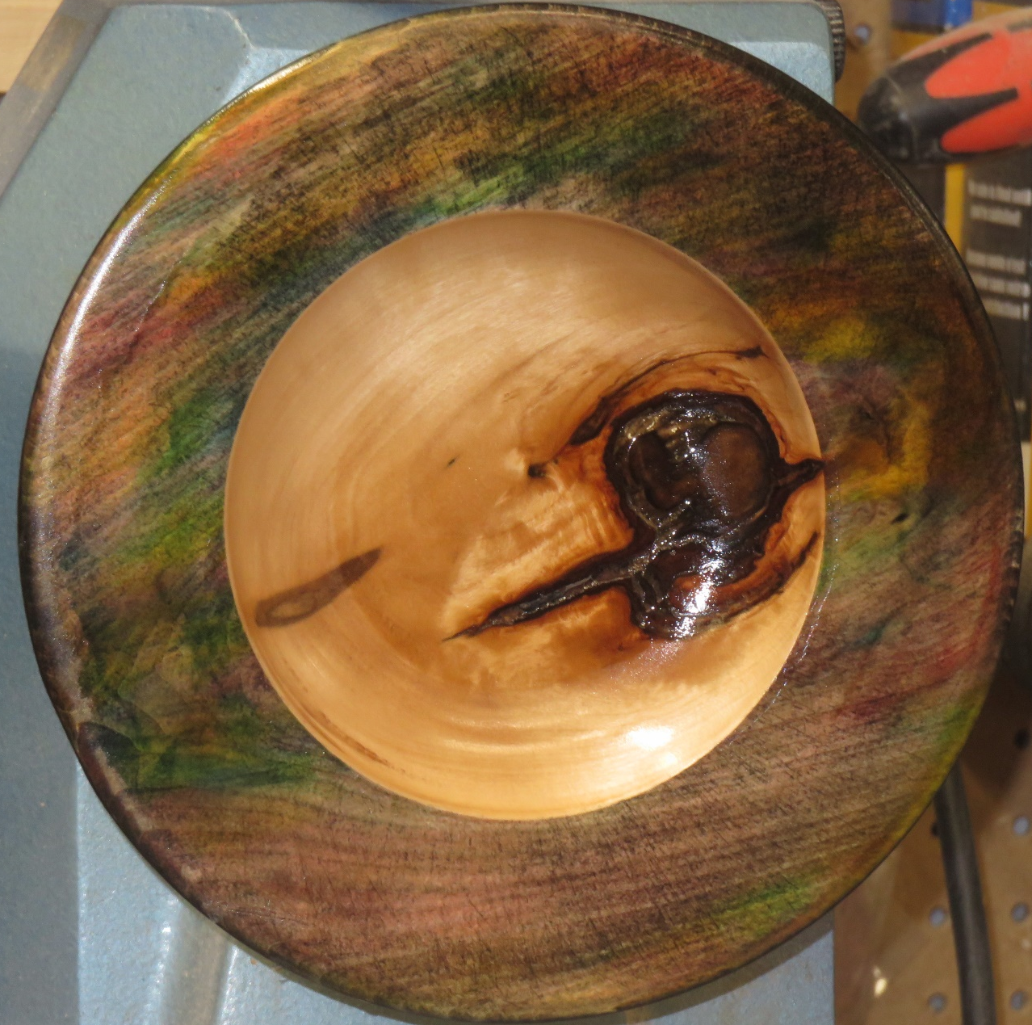

Safety Moment
Let’s Take a moment to talk about your SAFETY.
The Technique’s and Process’s presented in this demo reflects my approach to turning and colouring the rim of a bowl.
If you choose to follow this process you do so at your own risk
Please
- Read and Follow all the Safety recommendations provided by your tool Manufacturer
- Read and Use the Personal Protection Equipment Recommended by both the Tool and Product Manufacturers
Remember
You are responsible for your own safety

Tools and Supplies
Scroll Chuck, Wood Worm or Face Plate
Bowl Gouge – 1/2” or 3/8” bowel gouge
Round Nose Scraper
Sand Paper – 80 through 600 Grit recommended
Sanding Sealer of your choice – I use spray on Shellac (Available at Home Depot, Lowes, Paint Store s)
Alcohol Inks – Available from any art Store
Paper Towel
Latex/ Nitro lite Gloves – Automotive supply, Canadian Tire, Princess Auto etc.
Breathing Protection for Dusts, and V.O.C.’s

Blank Preparation
- Cut your blank square and mark the center.
- Draw your circle and cut it out on the band saw or jig saw if you have one, at the very minimum I strongly recommend cutting the corners off.
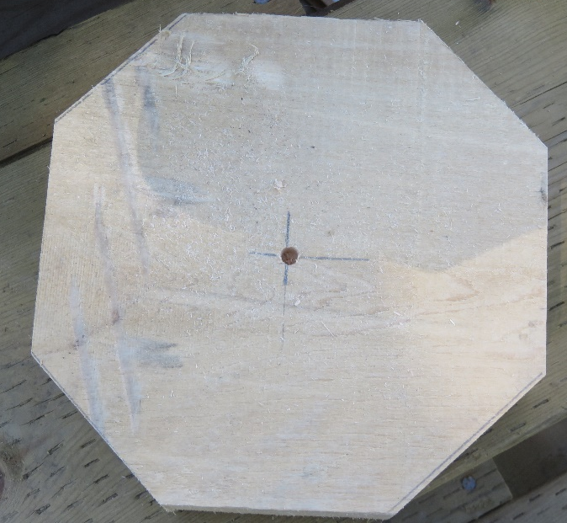

- Mount the blank on your lathe using either the Wood Worm Screw or Face Plate
- Turn and Finish the bottom of the bowl
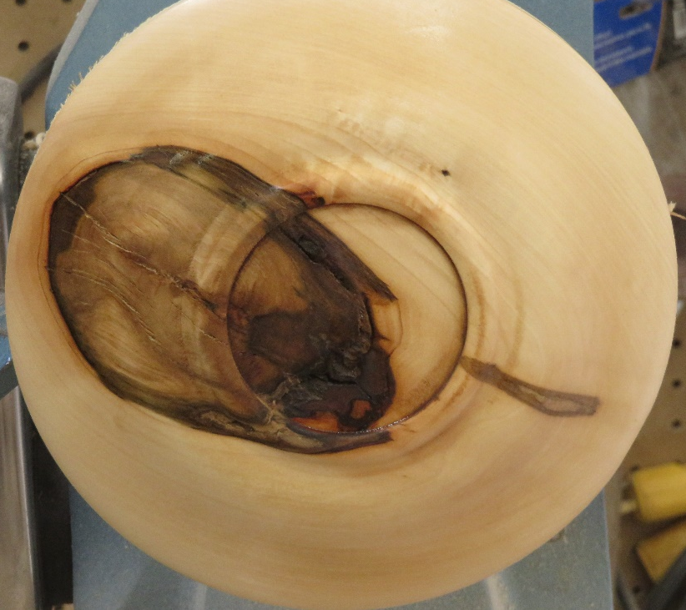
For this project I turn a recess for the chuck jaws. This allows me to totally finish the bottom of the bowl before moving on to the next step.
- Once you have the project reversed and mounted on the lathe turn the rim to its final thickness.
  - Use sand paper to round over or “soften” rim 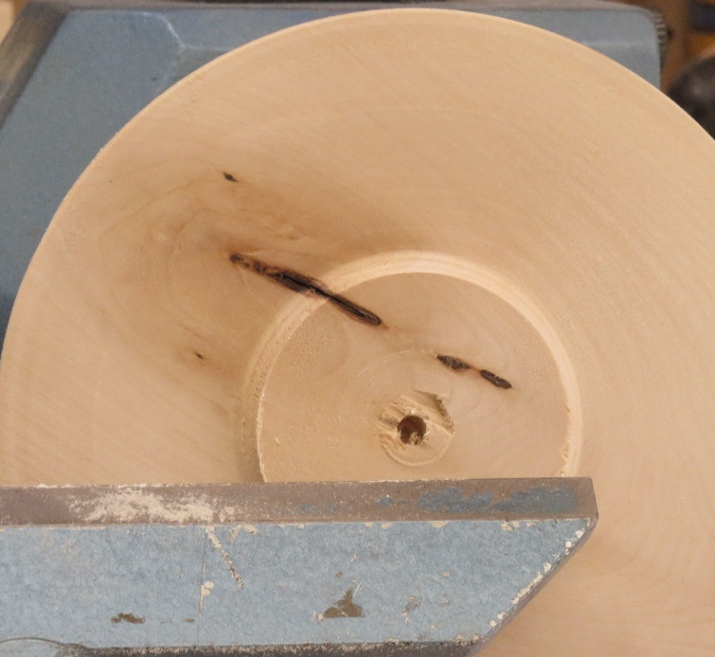

- Leave the Center of the bowl in at this point. If you were to turn the center out, the wood could (and probably will) move on you due to the release of internal stress in the blank If this happens you will have a very difficult time sanding and finishing the rim
- Sand and Finish the rim to 400g.

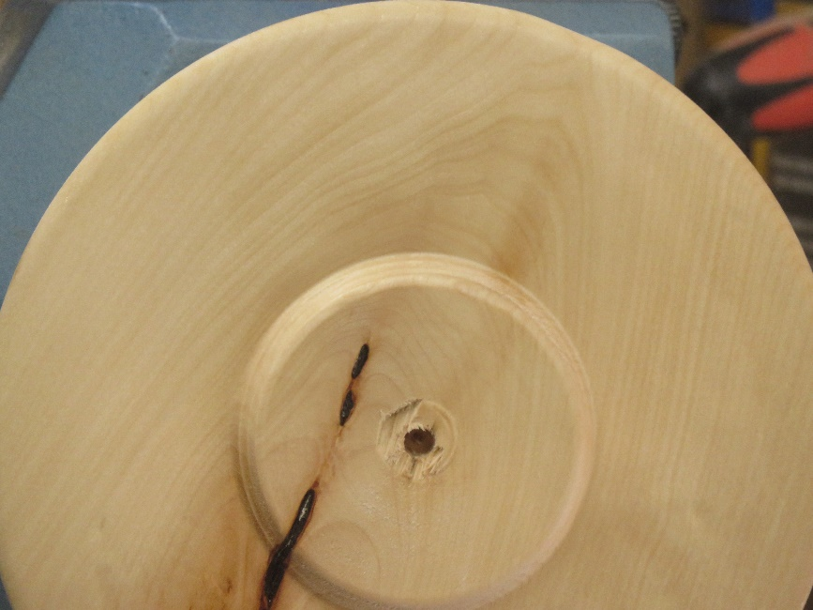

- After removing the sanding dust.
Seal the finished rim with a sanding sealer. Once dry sand the rim back with 320g and then back to 400g. The sealer will fill the pours of the wood and sanding it back will open the edges of the pours to accept the colour.
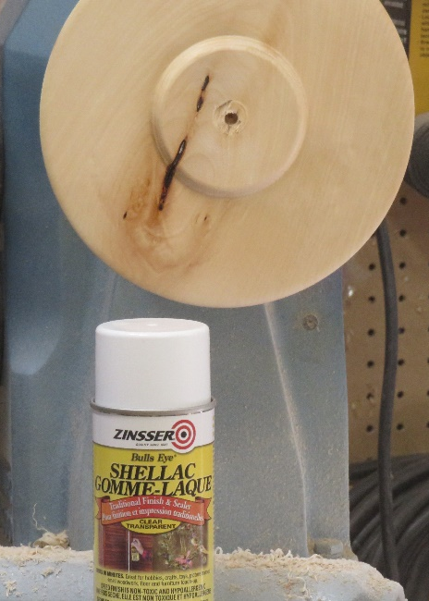
- Choose the colours that you want to use. Be sure to remember the gloves. The inks will leave a lasting reminder!
  - The other and more important thing is that the gloves will inhibit the alcohol from the ink being absorbed into your body through your skin.
- Choose your base colour and wipe it on to the rim with a paper towel. Let it dry and sand it back.
  - Dab on your secondary colour(s) and let them dry. Once you have the rim of the bowl coloured gently mist it with Isopropyl Alcohol to blend the colours together
  - Once everything is dry give the rim 3-4 coats of lacquer to seal in the colour.

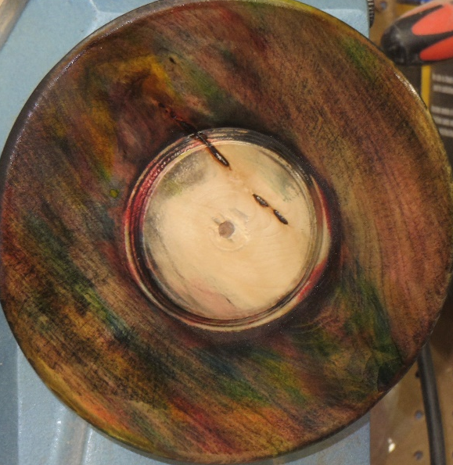

- Turn out the center
  - Use a parting tool to define the inner edge of the rim. This will give you a crisp line and provide a place to start your gouge to avoid having your gouge catch and skate across the finished rim .

- Sand and Finish the inside of he bowl .

